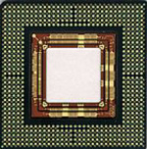 | BGA  Ball Grid Array | 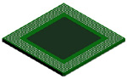 | EBGA 680L
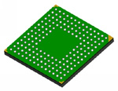 | LBGA 160L | 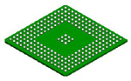 | PBGA 217L  Plastic Ball  Grid Array
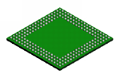 | SBGA 192L | 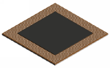 | TSBGA 680L
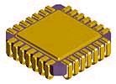 | CLCC | 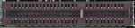 | CNR Communication and Networking Riser Specification Revision 1.2
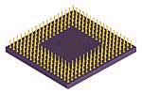 | CPGA Ceramic Pin Grid Array | 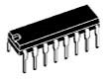 | DIP Dual Inline Package
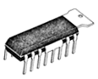 | DIP-tab Dual Inline Package with Metal Heatsink | 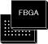 | FBGA
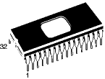 | FDIP | 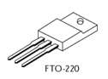 | FTO-220
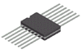 | Flat Pack | 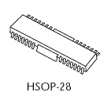 | HSOP-28
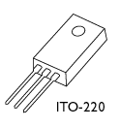 | ITO-220 | 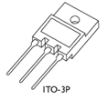 | ITO-3P
 | JLCC | 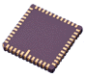 | LCC
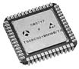 | LDCC | 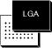 | LGA
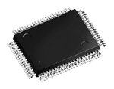 | LQFP | 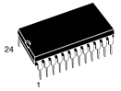 | PCDIP
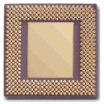 | PGA Plastic Pin Grid Array | 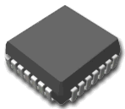 | PLCC
 | PQFP | 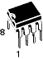 | PSDIP
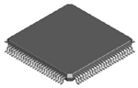 | LQFP 100L | 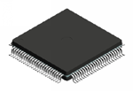 | METAL QUAD 100L
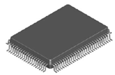 | PQFP 100L | 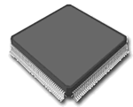 | QFP Quad Flat Package
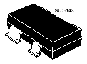 | SOT143 | 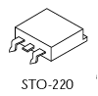 | SOT220
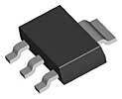 | SOT223 | 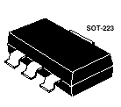 | SOT223
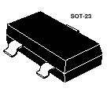 | SOT23 | 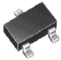 | SOT23/SOT323
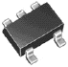 | SOT25/SOT353 | 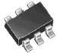 | SOT26/SOT363
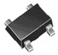 | SOT343 |  | SOT523
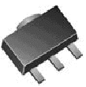 | SOT89 | 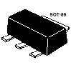 | SOT89
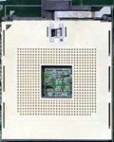 | Socket 603 Foster | 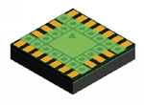 | LAMINATE TCSP 20L Chip Scale Package
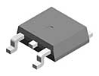 | TO252 | 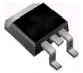 | TO263/TO268
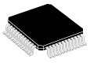 | QFP Quad Flat Package | 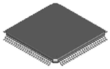 | TQFP 100L
 | SBGA | 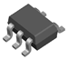 | SC-70 5L
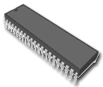 | SDIP | 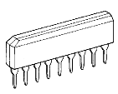 | SIP Single Inline Package
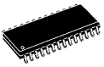 | SO Small Outline Package | 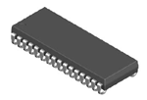 | SOJ 32L
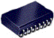 | SOJ | 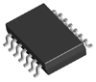 | SOP EIAJ TYPE II 14L
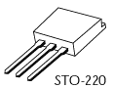 | SOT220 | 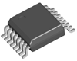 | SSOP 16L
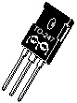 | TO247 | 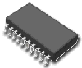 | SSOP
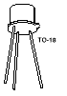 | TO18 | 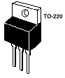 | TO220
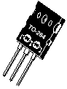 | TO264 |  | TO3
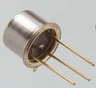 | TO5 | 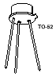 | TO52
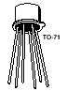 | TO71 | 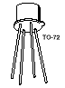 | TO72
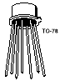 | TO78 | 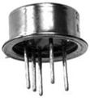 | TO8
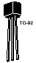 | TO92 | 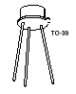 | TO93
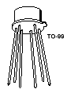 | TO99 | 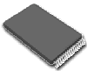 | TSOP Thin Small Outline Package
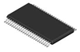 | TSSOP or TSOP II Thin Shrink Outline Package | 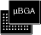 | uBGA Micro Ball Grid Array
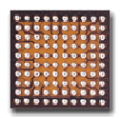 | uBGA Micro Ball Grid Array | 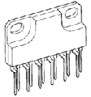 | ZIP Zig-Zag Inline Package
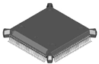 | BQFP132 | 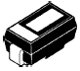 | C-Bend Lead
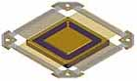 | CERQUAD Ceramic Quad Flat Pack |  | Ceramic Case
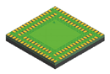 | LAMINATE CSP 112L Chip Scale Package | 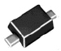 | Gull Wing Leads
 | PDIP |  | PLCC
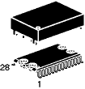 | SNAPTK | 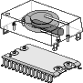 | SNAPTK

